African or American?: Conditional Nativism and Black American National Identity
Jennifer St Sume
University of Maryland, College Park

Author Note
DRAFT in preparation to meet the third-year paper requirement for the Doctoral program in Government and Politics.

Table of Contents
Abstract 3
African or American?: Conditional Nativism and Black American National Identity 4
Discrimination, Exclusion, and Identity Management 7
Racial Collectivism 10
Theory: Coping and Conditional Nativism 12
Methodology 15
Modeling 15
Results 17
Comparing to White Racial Collectivism 22
Discussion 26
Conclusion 28
References 29

Abstract
Black Americans have faced discrimination throughout all of American History. Still, Black Americans report similar levels of national identity to other groups. I argue that Black Americans have a unique disposition toward national identity known as conditional nativism. Conditional nativism is the process of employing racial collectivism to form a positive orientation toward national identity. Using a national sample of respondents from the 2016 Collaborative Multi-racial Postelection Survey (n = 10,146), I explore the role of conditional nativism in shaping Black American national identity. I find that while racial collectivism predicts a positive orientation toward national identity, the degree of racial collectivism produces a negative orientation toward national identity. These results underscore the role of racial collectivism and conditional nativism in Black American orientation toward national identity.
Keywords: Black, African American, national identity, race, identity

African or American?: Conditional Nativism and Black American National Identity

Black Americans are the only racial American group to have been explicitly rendered property and later integrated into the American national identity. Moreover, Black Americans (among other non-White, male, land-owning, and religious individuals) as an underclass of citizens in the United States' constitution (Shklar 1991). And so the legacy of racist classifications were institutionalized into the American constitution (Acharya, Blackwell, and Sen 2016). What is Black national identity? The answers to this question inform theories of identity, identity management, electoral behavior, and attitude formation. Thus, Black racial identity is a curious puzzle for political psychology and political science alike. This paper explores the unique sociopolitical position of Black Americans in the American superordinate identity I offer a race-based perspective on national identity and American politics. I argue that racial collectivism is a cognitive mechanism that allows individuals to improve an otherwise negative orientation toward national identity into a positive one. This mechanism that shapes an individual’s orientation toward national identity is what I refer to as conditional nativism. I describe the mechanisms of this orientation toward national identity to disentangle the relationship between racial and national identities for Black and other non-White Americans.
On one hand, Black Americans have sufficient right to feel “less” American than their non-Black counterparts from a legacy of exclusion. Additionally, Black Americans are definitively collectivistic (Dawson 1994) which contends with American individualism. Still, Black Americans national identity is a mixed bag. Figure 1 reports orientation toward national identity among four main racial subgroups of American national identity. Among Black Americans, 61% feel strongly that they belong in the United States, 95% felt any sense of Belonging at all. Comparatively, 76% of White Americans feel strongly that they belong to the American national identity while 93% feel. Unsurprisingly, however, Black Americans are most likely to feel strongly like an outsider (7%) excluded from their national identity (7%). In summary, Black Americans as a subgroup feel both positively and negatively toward their national identity.

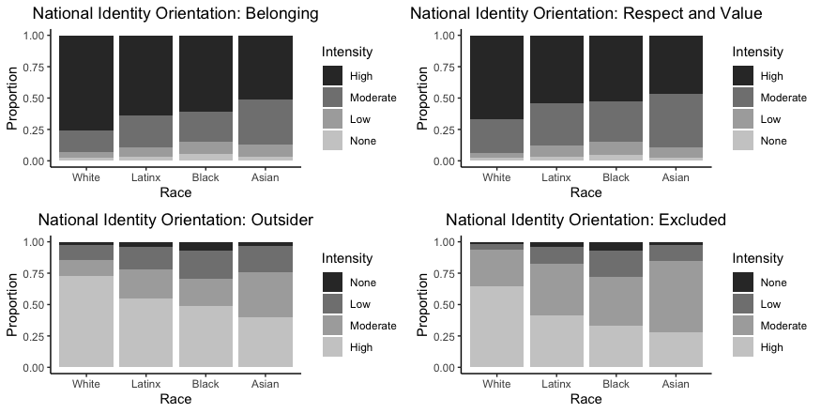
Figure 1 reports national identity orientation by racial groups. Each dependent variable is a constituent item of the national identity index I use in Model 1. The x-axis reports racial groups while the y-axis reports the proportion of each group that shares the attachment (Collaborative Multi-Racial Post-Election Survey, n = 10,146).

Black Americans form a different orientation toward American national identity I call conditional nativism. I define conditional nativism as the idea that individual attachment to national identity is conditional on their racial group well-being. Thus, if individuals are cued with information about their racial group they are more likely to feel positively toward it as they have not experienced the same level of exclusion from their racial group as their national identity The process through which racial collectivism shapes individual attachment to national identity is the topic of this paper.
This disposition is both politically consequential and theoretically imperative to the study of American politics. First, one’s attachment to national identity can predict their political behavior (Dalton 2008; Klandermans 2014; Rosenstone and Hansen 1993; Valenzuela and Michelson 2016a). Black Americans are a cohesive and engaged groups in American politics. Black voter turnout peaked in 2008, with 65.7% of voters turning out for the presidential election (Pew 2017). In 2012, Black Americans surpassed White voter turnout, and 66.6% of Black voters turning out. Second, the lingering uncertainty of the inclusion of Blacks was the impetus for Donald Trump’s birther conspiracy. In 2008, Donald Trump famously challenged the birthplace and citizenship of President Barack Obama to kickstart the birther movement. While much of these attitudes can be attributed to racial attitudes (Tesler 2015), Black American national identity was the object of contention. Thus, how Black Americans perceive their national identity themselves is part of a larger discussion about how Americans as a superordinate identity view Black American national identity. The process through which individual use their racial identity to orients Black American national identity is what I refer to as conditional nativism.
The story of this paper is as follows. I begin by describing race as the United States' fundamental cleavage that forged a White-Black dichotomy of American national identity. I then review social identity theory highlighting how individuals manage cross-pressures between conflicting identities. I propose that conditional nativism is a mechanism to alleviate the pressures of competing identity concerns. I use survey data from the 2016 Collaborative Multi-Ethnic Post Election Survey to model Black attachment to national identity. I find that Black Americans who report racial collectivism are more likely to hold negative views toward their national identity than non-Black. Together, this paper suggests a theory for understanding the relationship between racial (subgroup) and national (superordinate group) identities for low status groups.

Discrimination, Exclusion, and Identity Management
Social identity theory argues that individuals self-categorize into identity groups (Tajfel et al. 1971; Tajfel and Turner 1979). Individuals who are members of a group learn the nature, norms, and values of the group and assume these as their own. Additionally, members of a group pay special attention to the status of a group. When a group is threatened, the members react emotionally. While identities may serve as political tools, identities are not inherently political. Their identity becomes politicized when identification with a group combines with a desire to advance group goals through collective action (Miller et al. 1981). In sum, group identities are tools that communicate norms, values, and beliefs to group members and non-members alike. Individuals identify strongly with their group are motivated to act in their group's political interests.
Groups carry member prototypes or expectations of the nature of a group member. In the case of the United States, the national identity is associated with being White (Devos and Banaji 2005). Why is this so? Centuries of White domination of political spaces have forged a race-based definition of the American national identity. As a result, Black Americans have and continue to be systematically excluded from the American body politic (Shklar 1991). Race-based exclusion has made it difficult for Black Americans to attach themselves to the American national identity. Racial assimilation is impossible because of the immutability of Black skin (Chandra and Wilkinson 2008). While one can move to another country, one cannot move to another racial category. Black Americans are left to negotiate their position through political processes, including, but not limited to, such actions like voting, mobilizing group interests, and forming winning political coalitions within the public.
Another consequence of race-based exclusion from the American national identity is the feeling of exclusion itself. Exclusion creates negative psychological stress because it violates the individual's need for belongingness (Baumeister and Leary 1995; Tajfel and Turner 1979). Exclusion feels a lot like rejection, and rejection is a painful experience (Tajfel and Turner 1979; Turner, Brown, and Tajfel 1979). When the status of an individual's identity becomes threatened by exclusion, such as Black Americans, an individual is motivated to relieve any negative psychological stress associated therein (Brewer 1999).
Within a large superordinate identity, such as the United States’ American identity, there are a variety of subgroups. Subgroups are commonly arranged in a hierarchy (Turner and Brown 1978 cite). Social identity theory states that group hierarchies and resource competition contribute to intergroup conflict (Tajfel and turner cite, Brewer cite). The same should apply to intragroup conflict, or the competition of subgroups within a larger superordinate identity. In the United States’ hierarchy, Blacks are a relative low status group. Thus, the landscape of my puzzle is two-dimensional. The first dimension is exclusion from the superordinate identity (intragroup). Second, the relative position of the racial subgroup within the superordinate national identity (Carter and Pérez 2016).

I define national identity as the individual feeling of being part of a nation. Rupert Emerson defined national identity as “a body of people who feel that they are a nation (Emerson 1960, p. 102). I operationalize national identity through the framework of social identity theory. In this way, national identity is a group with which an individual might self-categorize and form affect. Social identity theory "provides guidance on the measurement of national attachments, produces a nonideological measure that evades contention over the meaning of American patriotism, and generates testable and empirically substantiated predictions" of individual behavior (Huddy and Khatib 2007, p. 74).
Importantly, national identity is different than symbolic, constructive, uncritical patriotism, nationalism (Huddy and Khatib 2007); and citizenship (Dalton 2008); is akin but distinct from nationalism (Huddy and Khatib 2007) and least like patriotism (Huddy and Khatib 2007; McDaniel, Nooruddin, and Shortle 2016). There are three major values associated with the American national identity. First, Americans believe that Americans speak English and believe in God. Next, perception of American identity influences perception of minorities and society's well-being. Finally, that Americanism is a symbolic predisposition to national identity. This includes racial and religious expectations of a citizen as described through civic "duty” (Citrin, Reingold, and Green 1990). As a measure, national identity outperforms all other measures in ability to predict civic engagement (Huddy and Khatib me 2007). National identity has equal endorsement from conservatives and liberals alike and improves among immigrant groups over time. Finally, national identity evades racial differences in opinion.
Do individuals care about their racial or national identities more? Political science remains uncertain of the answer. Triandafyllidou (2010) argues that national identity is the most important for all persons in a nation. However, non-White orientation toward national identity is driven by racial collectivism (Citrin, Wong, and Duff 2001). Interestingly, White Americans are the only group for which prioritizing race over national identity only influences attitudes. Only Whites said they view themselves as just American (78%). Black Americans were most likely (27%) to say they view themselves as Black exclusively. Moreover, Huddy and Khatib (2007) find Blacks have a negative orientation toward national identity. Thus the question of the relationship between racial and national identity is left unanswered.
So far, the literature has identified that national identity cues operate differently for racial groups. However, little research considers the mechanism that motivate national identity to vary by race. In other words, how do non-White Americans form their orientation toward national identity? I argue persistent racial discrimination has left non-White Americans feeling excluded from the national identity. As a result, non-White groups have chosen alternative mechanisms to understand their own national identity. The mechanism through which non-White Americans infer their national identity is what I refer to as racial collectivism. I explain the role of racial collectivism below.

Racial Collectivism
In Behind the Mule, Michael Dawson (1994) introduces the concept of linked fate. Linked fate is the measurement of how much the outcomes of a group, in this case, Blacks, are included in individual political behavior. Linked fate is a utility heuristic that helps determine the extent to which individual actions (inaction) can produce group-level benefits (costs). The theory of linked fate has been extended to use for other racial and demographic identifiers, but not always appropriately so. One common concept that is used interchangeably with linked fate is group consciousness. Group consciousness is the belief that what happens to others in one’s group will affect themselves personally. Racial group consciousness is the belief that political action is the best means to improve political conditions. Much of Black political behavior is in favor of group interests.
In total, there are three dimensions of group consciousness: group identity, recognition of the disadvantaged status, and desire for collective action (Garcia 2003; Miller et. al. 1981). Are the concepts of linked fate and group consciousness interchangeable? Evidence suggests that this is only true for Black Americans ((Stephens-Dougan 2016)Sanchez and Vargas 2016). For non-Blacks, linked fate operates on a different theoretical and empirical dimension than group consciousness. Sanchez and Vargas (2016) conduct factor analysis on the linked fate measure. They find only Blacks returned a one-factor solution for the group consciousness and linked fate. For non-Blacks, group consciousness and linked fate are distinct.
Why are they different? A history of shared discrimination drives linked fate for Blacks and Asians. In contrast, language preference and nativity drive Latino linked fate. In short, linked fate is different for Blacks because they are the only racial group to be enslaved and later integrated into the American electorate. This distinction is important for understanding Black and non-Black political behavior, particularly when employing measures of linked fate and group consciousness.
In summary, linked fate is a utility heuristic for Black American political behavior. Because Blacks are afraid of behaving in a way that might present costs to the rest of their group, individuals are constrained by following their self-interest. Together, social conformity and internalized beliefs about group solidarity depress self-interested behavior for Black Americans (White, Laird, and Allen 2014). Research has also shown that all Americans use an identity-based approach to forming their partisan identity (Kuo, Malhotra, and Mo 2017; Margolis 2017; Mason and Wronski 2018). In sum, racial collectivism powerfully shapes Black American political behavior.

Theory: Coping and Conditional Nativism
The first recorded law of the United States explicitly limited citizenship to members of the White racial groups (Naturalization Act of 1790, cite). For centuries citizenship, and by proxy national identity, was limited to those White, Anglo-Saxon, protestants privileging their relative access to political and economic activities. Policy cues further solidified Black individuals' "Otherness" from public life and, ultimately, national identity (Vargas, Sanchez, and Valdez 2017). These divisions were further reinforced informally through social policing. Following Reconstruction, Jim Crow laws isolated Blacks from Whites in all public domains. These included racial minorities systematic exclusion from resources, education, gainful employment, and the various remaining norms and protections of civic life. The contemporary rise of mass incarceration renews the promise of racial exclusion for as many as 1 in 3 Black American men (Alexander and West 2020). Thus, citizenship, policy, and exclusion cues confirm the racial stratification of national identity -- forging distinct experiences of national identity for White and Black Americans.
In response to racial segregation, Black Americans have adopted a collectivist subgroup norm (Dawson 1994). As a subgroup norm, collectivism contradicts the American group norms of individualism. Importantly, the American national identity is rooted in the norms of neoliberalism, Protestantism, individualism, and self-sufficiency (Citrin, Wong, and Duff 2001). Neoliberal norms of individualism and free enterprise (agency) permeate the American body politic in stark contrast to Black American communal norms. Thus, two powerful forces challenge Black American national identity - White supremacy and linked fate.
Why is racial collectivism a unique and powerful force for Black political behavior? Black individuals withhold from pursuing self-interest over group interests because of the perceived cost to other Blacks (White, Laird, and Allen 2014). Thus, Black collectivism encourages individual conformity. Furthermore, a sense of linked fate predicts racial groups members' political behavior, including increased political participation, greater support for inter-racial group coalitions, liberal views about policy, high participation rates, and the behavior of political elites (Dawson 1994; Miller et al. 1981; Sanchez 2006a; Sanchez and Vargas 2016).
There are two possible effect of the role of racial collectivism. First, Black Americans are likely to evaluate how Blacks as a whole have been discriminated against when evaluating their attachment to national identity. In the case of American national identity, opposition to White Supremacy is a crystalized and salient norm (Carter and Pérez 2016). In this scenario, Black Americans will have a negative orientation toward national identity.

H1: Those who report collectivist attitudes will have a negative orientation toward national identity.

Second, Blacks Americans may cope with this negative feeling by choosing an alternative referent group through which to evaluate national identity (Shinnar 2008; Turner, Brown, and Tajfel 1979). In this view, racial collectivism provides an alternative axis to orient one’s national identity.

H2: Those who report collectivist attitudes will have a positive orientation toward national identity.

I expect those who report the highest levels of linked fate to report different levels of racial collectivism than those who feel the lowest levels of linked fate. We know that an individual’s attachment to an identity is distinct from membership in a identity group with consequences for political behavior (Green, Palmquist, and Shickler 2002; Huddy, Mason, and Aarøe 2015a; Suhay 2014). Since I am unsure of the nature of conditional nativism as a mechanism, I remain agnostic to the potential role of collectivist intensity.

H3: Strong racial collectivist will report different national identity than low racial collectivist.

In summary, the process of evaluating one’s national identity is my central puzzle. I define conditional nativism as the identity-based process of orienting toward the American national identity. Racial collectivism is the mechanism that motivates Black Americans to evaluate their behavior in the context of group outcomes. In this way, racial collectivism is a utility heuristic that helps determine how individual actions (or inaction) can produce group-level benefits (or costs).
Finally, my theory suggests that racial collectivism is a coping mechanism for low-status group within the American national identity.
The corollary of that is that racial collectivism will not be meaningful to White Americans as the dominant racial group. If this is true, collectivism should operate differently for Whites as the dominant racial group.

H4: Racial collectivism will influence low-status and not dominant groups.

Methodology
This paper is based on an analysis of the 2016 Collaborative Multiracial Post-Election Survey (Barreto et al. 2017). The 2016 CMPS includes more than 10,000 respondents, including 1,032 "Whites"; 3,102 "Black/African Americans"; 3,003 Latinx (Latinx/a"/"Hispanic"); and 3,006 "Asian"/" Asian Americans" all self-identified. The survey was conducted via a "random to web" method such that emails were selected randomly from registered voters and commercial vending lists. Individuals associated with those emails were contacted and invited to participate in an online survey. Approximately 40% of the individuals on registered voter lists provided an email address. Invitations and surveys were provided in a bilingual format (English, Spanish, Chinese, Korean, and Vietnamese). The response rate was 9.9%.
While the CMPS is not a truly representative sample, the full data are weighted within each racial group to match the adult population in the 2015 Census ACS 1-year data file for age, gender, education, nativity, ancestry, and voter registration status. A post-stratification raking algorithm was used to balance each category within +/- 1 percent of the ACS estimates. Additionally, the number of Whites in the sample (n=1,032) is sufficient to make meaningful comparisons and inferences from the data.

Modeling
My dependent variable is “national identity.” National identity describes a sense of belonging to a nation and the collection of cultural and economic processes that make "imagining" a nation possible (Triandafyllidou 2010). Conceptually, this captures an individual's self-identification as a member of the American identity. Note that I operationalize national identity as separate from citizenship. National identity is an individual's self-identified allegiance to the United States of America and its governing values. I am interested in how individuals perceive their national identity. I forge a national identity index using a variety of national identity items. Together these items capture a respondent’s orientation toward national identity.
My primary measure of interest is “racial collectivism.” To do so, I use the traditional measure of linked fate, "Do you think what happens generally to [racial group] people in this country will have something to do with what happens in your life?" This captures the role of collectivism in orientation toward national identity. This variable takes on the value of "1" if the respondent is collectivist and "0" if the respondent is individualistic. If my theory is correct, I expect linked fate to forge negative views of national identity. I include a second measure of collectivism, degree of linked fate. Among those who report linked fate, respondents are asked to select whether collectivism matters “not very much,” “somewhat,” or “a lot” to their individual outcomes. Intensity of linked fate captures the degree to which individuals feel collectivism matters to their own life. If my theory is correct, the intensity of linked fate will also create a negative perception of national identity.
Finally, l control for other factors related to identity, including income, age, citizenship, female, education, partisanship, and native-born. I measure income, age, and education as categorical variables. Partisanship is dichotomous where “1” takes on the value of a partisan and “0” indicates a non-partisan. Further, native born takes on “1” if the individual is born here and “0” if they are not.

Results
In general, I am interested in how attachment to national identity will vary by race. Specifically, I am interested in Black American attachment to national identity. Further, I am interested in the role of collectivism on orientation toward national identity. I expect two things. First, racial collectivism should shape Black American orientation toward national identity. Model 1 reports the role of collectivism in orientation toward national identity. Descriptive statistics demonstrate that this is a possible explanation. This runs counter to my second hypothesis. Second, that Black Americans with high racial collectivism will behave differently than individuals with low racial collectivism.
I begin with the role of racial collectivism in Black American national identity. Model 1 reports the role of collectivism among Black Americans. Racial collectivism makes Black Americans 12% more likely to have a positive orientation. This supports my second hypothesis that racial collectivism creates a positive orientation toward national identity ceteris paribus. In this view, racial collectivism provides Black Americans with an alternative referent to form their attachment to national identity. Thus, when asking a Black American whether what happens to Black people matters to their national identity, you are also cueing any positive associations with the racial group. In practice, this suggests that Black Americans to build a positive disposition to their national identity by considering their positive affective connection to Blacks as a racial group.

Black Collectivism and National Identity
 | Dependent variable:
 | National Identity
 | (1) | (2) | (3)
Citizen | 0.04 | 0.06 | -0.01
 | (0.15) | (0.15) | (0.17)
Female | 0.05** | 0.05* | 0.05
 | (0.03) | (0.03) | (0.03)
Native Born | 0.06 | 0.06 | 0.14
 | (0.14) | (0.14) | (0.16)
South | -0.02 | -0.03 | -0.05*
 | (0.02) | (0.02) | (0.03)
Income | 0.00 | 0.00 | 0.00
 | (0.003) | (0.003) | (0.004)
Linked Fate |  | 0.12***
 |  | (0.02)
Moderate LF |  |  | -0.10*
 |  |  | (0.06)
High LF |  |  | -0.23***
 |  |  | (0.06)
Partisanship | 0.03 | 0.03 | 0.04
 | (0.03) | (0.03) | (0.03)
Education | -0.01 | -0.003 | -0.01
 | (0.01) | (0.01) | (0.01)
Age | 0.004*** | 0.004*** | 0.003***
 | (0.001) | (0.001) | (0.001)
Intercept | 1.07*** | 1.01*** | 1.20***
 | (0.07) | (0.08) | (0.11)
Observations | 2,286 | 2,286 | 1,570
Akaike Inf. Crit. | 3,728.81 | 3,707.49 | 2,558.80
Note: Table 2 reports the results of three models measuring the role of racial identity and collectivism among Black Americans. Model 1 captures national identity without racial collectivism. Model 2 measures the role of the collectivist identity on orientation toward their American national identity. Model 3 measures the role of intensity of collectivism on perception of national identity. All coefficients are the log-odds of a positive perception of one’s American national identity (alpha = .05). | ^{*p<0.1; **p<0.05; ***p<0.01}

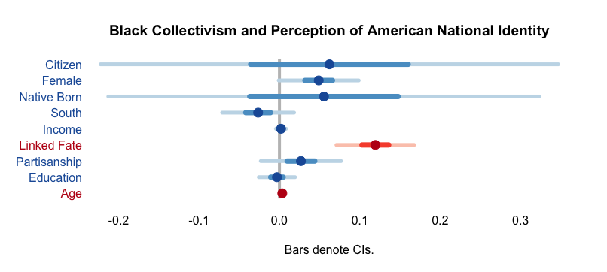
Figure 2 displays the results of Model 3. Here I isolate the effect of collectivism on orientation toward national identity among Black Americans. Coefficients are the log-odds of positive orientation to the American national identity. Bars denote 95% confidence intervals. Red bars are statistically significant (alpha = .05). Blue bars are statistically insignificant (alpha = .05).
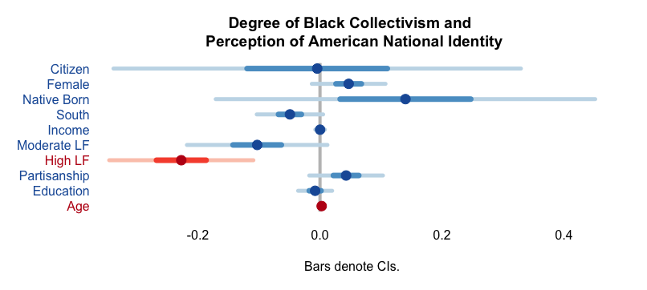
Figure 3 displays the results of Model 4. Here I isolate the effect of the intensity of collectivism on orientation toward national identity among Black Americans. Coefficients are the log-odds of positive orientation to the American national identity. Bars denote 95% confidence intervals. Red bars are statistically significant (alpha = .05). Blue bars are statistically insignificant (alpha = .05).

My third hypothesis predicts those with the highest levels of racial collectivism will have a different orientation toward national identity than those with low racial collectivism. Model 2 looks at the role of degree of collectivism on positive orientation toward national identity. Statistically, there was no difference between individuals who report moderate collectivism and those who reported low collectivism on positive orientation toward national identity. However, those who reported high collectivism were 23% less likely to have a positive orientation toward national identity than those who reported moderate collectivism. All in all, the data supports my hypothesis that those strong racial collectivist will behave differently than weak racial collectivist.
This becomes important when we consider the distribution of high collectivists among Black Americans. In total, 37% of Blacks reported high levels of collectivism. For Latinos 31% of them reported high collectivism. Whites followed next with 25% and, finally, 20% of Asians reported high collectivism. While most individuals believe what happens to their racial group matters to their individual life regardless of race, the distribution of collectivist intensity varies by racial groups. Over one third of Black Americans feel, strongly, that their racial group status matters to how they view themselves and their national identity. This suggests that Blacks as a racial are distinct in the saturation of individuals with intensely collectivist attitudes.

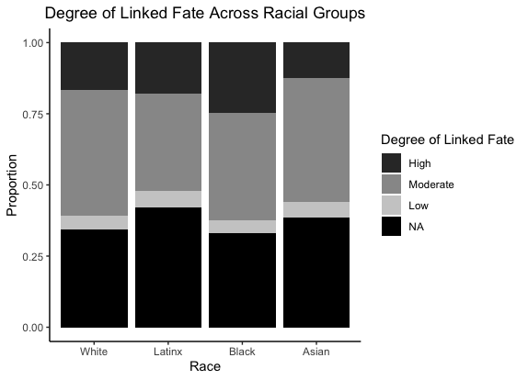
Figure 3 displays the degree of linked fate across racial groups (Collaborative Multi-racial Post-election Survey, n = 10,146). In total, 37% of Black Americans report strong collectivism. Black Americans demonstrate the highest concentration of individuals with strong collectivism.

Comparing to White Racial Collectivism
I now compare the role of racial collectivism for White Americans. Doing this allows me to isolate the effect of collectivism for White Americans. Table 2 reports three models measuring White American national identity. Model 2 reports the role of racial collectivism in White national identity. The effect of racial collectivism on White national identity is both zero and statistically significant. Unsurprisingly, the level of racial collectivism does not influence White national identity. This supports my theory that conditional nativism is a mechanism for low-status groups.
Two important lessons arise from my evaluation of White racial collectivism. First, the use of racial collectivism varies across racial groups. This is because the substance of White American racial collectivism is distinct from non-White Americans. Second, the data underscores that White American are relatively individualistic to their non-White counterparts (Sanchez and Vargas 2016).

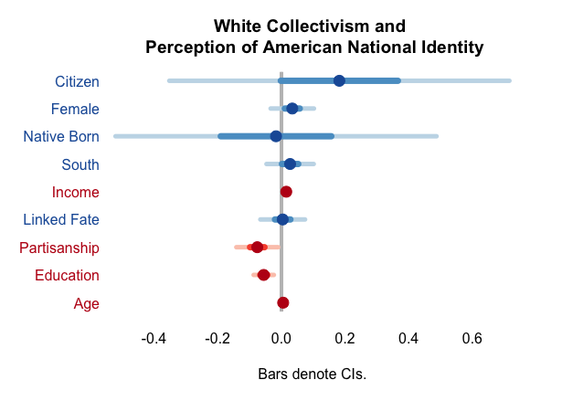
Figure 5 displays the results of modeling White American racial collectivism. Here I isolate the effect of collectivism on orientation toward national identity among Black Americans. Coefficients are the log-odds of positive orientation to the American national identity. Bars denote 95% confidence intervals. Red bars are statistically significant (alpha = .05). Blue bars are statistically insignificant (alpha = .05).

White Collectivism and National Identity
 | Dependent variable:
 | National Identity
 | (1) | (2) | (3)
Citizen | 0.18 | 0.18 | -0.05
 | (0.27) | (0.27) | (0.14)
Female | 0.03 | 0.03 | 0.04
 | (0.03) | (0.03) | (0.04)
Native Born | -0.02 | -0.02
 | (0.26) | (0.26)
South | 0.03 | 0.03 | 0.04
 | (0.04) | (0.04) | (0.05)
Income | 0.02*** | 0.02*** | 0.02***
 | (0.005) | (0.005) | (0.01)
Linked Fate |  | 0.004
 |  | (0.04)
Moderate LF |  |  | -0.05
 |  |  | (0.08)
High LF |  |  | -0.07
 |  |  | (0.09)
Partisanship | -0.08** | -0.08** | -0.09**
 | (0.03) | (0.03) | (0.04)
Education | - 0.06*** | -0.06*** | -0.07***
 | (0.02) | (0.02) | (0.02)
Age | 0.01*** | 0.01*** | 0.01***
 | (0.001) | (0.001) | (0.001)
Intercept | 1.23*** | 1.22*** | 1.51***
 | (0.13) | (0.13) | (0.19)
Observations | 714 | 714 | 478
Akaike Inf. Crit. | 855.35 | 857.34 | 588.31
Note: Table 2 reports the results of three models measuring the role of racial identity and collectivism among White Americans. Model 4 captures national identity without racial collectivism. Model 5 measures the role of the collectivist identity on orientation toward their American national identity. Model 6 measures the role of intensity of collectivism on perception of national identity. All coefficients are the log-odds of a positive perception of one’s American national identity (alpha = .05) | ^{*p<0.1; **p<0.05; ***p<0.01}

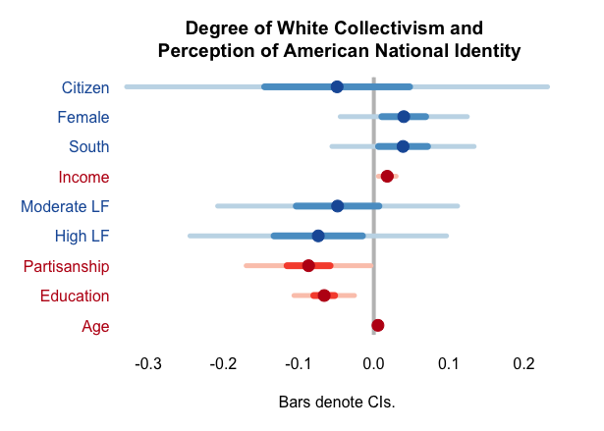
Figure 6 displays the results of modeling the intensity of White American racial collectivism. Here I isolate the effect of the intensity of collectivism on orientation toward national identity among Black Americans. Coefficients are the log-odds of positive orientation to the American national identity. Bars denote 95% confidence intervals. Red bars are statistically significant (alpha = .05). Blue bars are statistically insignificant (alpha = .05).

Discussion
The role of collectivism in orientation toward national identity is complex. On one hand, the presence of collectivism activates a racial collectivism. In theoretical terms, this suggests that Black Americans have an additional heuristic through which to reframe their orientation toward national identity. This might explain why national identity cues differ across racial groups (Sanchez 2006b; Transue 2007; Valenzuela and Michelson 2016b). This adds to growing literature that argues that identities influence political behavior (Huddy, Mason, and Aarøe 2015b; Kuo, Malhotra, and Mo 2017; Margolis 2017; Mason and Wronski 2018).
Two important patterns emerge from the data. First, for Black Americans, collectivism is who they are, not what they do. Black Americans are more likely to have collectivist beliefs than any other racial group. The salience of racial collectivism provides an alternative referent to understand one’s relative position as an American. Since all Blacks are in the United States, they feel positive toward their national identity because they are aware they are not alone in their collective aim for subgroup well-being. As a result, racial collectivism motivates individuals to form a positive orientation toward national identity. So long as other Black Americans are present in the United States there is sufficient motivation to feel positively toward their national identity. Conditional nativism provides a way for Black Americans to fee positively toward their American identity. In this way, conditional nativism satisfies the psychological need to feel positively toward their national identity as a group member (Tajfel et al. 1971; Tajfel and Turner 1979).
There are two reasons why racial collectivism works for low status groups. First, linked fate operates differently for each racial group (Dawson 1994; Sanchez and Vargas 2016). As Latino, White, or Asian American collectivism differs so might their respective roles in orientation toward national identity. So, while this theory may transfer to some national identity subgroups, it may not transfer to all. Second, Black collectivism is specifically defined by experiences of discrimination (Sanchez and Vargas 2016) and enacted by improving the social, economic, and political of the subgroup (Dawson 2011). Racial collectivism as an identity allows Black Americans to feel connected to the American identity because Blacks are aware that they share this national identity – with all discrimination and potential therein -- with other Blacks.
Second, strong racial collectivists behave differently than weak racial collectivist. An individual’s degree of collectivism articulates the level of attachment to their subgroup. For all Black Americans groups, racial collectivism created a positive orientation toward national identity. However, among Blacks only those with the highest level of collectivism held a negative perception of their national identity. Empirically, this suggests that racial collectivism is conceptually distinct from the intensity of one’s racial collectivism. Theoretically, this suggests that those who feel most attached to their racial group are more likely to be aware of threats and discrimination toward the racial group.
The distinction between identity membership and identity salience fits in with current theories of social identity. For example, partisan identities, for example, are distinct from intensity measures of partisanship (Green, Palmquist, and Shickler 2002). Partisan identities are group identities and reflect an individual’s attachment to that group. Alternatively, intensity of partisanship measures the degree of attachment to that group. Furthermore, the degree of attachment to a group predicts political behavior. Strong attachment to a group predicts different behavior than weak attachment (Campbell et al. 1960; M. Dawson 1994; Green, Palmquist, and Shickler 2002). One’s relationship between racial and national identity predicts individual attitudes toward minority groups (Citrin, Reingold, and Green 1990); policy attitudes (Citrin, Wong, and Duff (2001); the effectiveness of national identity cues (Transue 2007; Valenzuela and Michelson 2016); and partisanship. (Kuo, Malhorta, and Hyunjung Mo (2017). Understanding the role of conditional nativism may offer insight into the forces that drive Black American patriotism, partisanship, and participation in American Politics.

Conclusion
In response to race-based exclusion from national identity, Black Americans have implemented a conditionally native orientation toward national identity. I combine major themes from social identity and political psychology to observe Black orientation toward the American national identity. Conditional nativism is shaped by Black collectivism and the awareness of their subgroup status. Racial collectivism is the mechanism through which they feel positive toward their national identity. If conditional nativism is the process, then collectivism, or racial collectivism, is the mechanism through which Black Americans form their national identity.
Theoretically, this suggests that non-White Americans have an additional heuristic through which to process information concerning national identity. While this study is insufficient to conclude the role of racial collectivism, it does provide a starting point for understanding Black American national identity in the United States. Specifically, Black Americans are not uniquely “racial” but uniquely collectivistic. Thus, their strong sense of racial collectivism serves as a mechanism for processing information related to the American national identity.
I contribute a nuanced look at citizenship through the lens of identity politics. While this paper is not meant to survey the entire structure of conditional nativism, there are several lessons to draw from these conclusions. First, when we fail to isolate non-White groups in our measurement, we introduce unnecessary error into our models. Second, racial collectivism is a powerful mechanism for non-White Americans. I demonstrated that racial collectivism improves Black orientation toward national identity. While Black Americans are comforted by the presence of other Blacks to produce a positive national identity, the role of racial collectivism varies by intensity. Those who report highest levels of collectivism are more likely to hold negative views. Together, these results suggest collectivism plays a complex yet central role in Black American attachment to national identity. Second, this paper underscores the need for accurate measurement of non-White political behavior by comparing Blacks to non-Blacks and not just White Americans.
Finally, this underscores other research that notes that social identities influence our partisan identities (Margolis 2017; Mason 2018). Further, this work underscores the need to study conditional nativism as a politically relevant mechanism subgroup conflict. Finally, it might be easy to finish this paper because Black Americans feel "unAmerican." However, that would be an incorrect interpretation. Instead, I argue that Black Americans manage their feelings of discriminatory exclusion from the American national identity with a subgroup-based orientation toward their national identity.

References
Acharya, Avidit, Matthew Blackwell, and Maya Sen. 2016. “The Political Legacy of American Slavery.” Journal of Politics 78(3): 621–41.
Alexander, Michelle, and Cornel West. 2020. The New Jim Crow: Mass Incarceration in the Age of Colorblindness The New Jim Crow: Mass Incarceration in the Age of Colorblindness. 10th ed. New York: The New Press.
Barreto, Matt et al. 2017. “The Collaborative Multiracial Post-Election Survey (CMPS).”
Baumeister, Roy F, and Mark R Leary. 1995. “The Need to Belong: Desire for Interpersonal Attachments as a Fundamental Human Motivation.” Psychological Bulletin 117(3): 497–529.
Brewer, Marilynn B. 1999. “The Psychology of Prejudice: Ingroup Love or Outgroup Hate?” Journal of Social Issues 55(3): 429–44.
Campbell, Angus, Philip E Converse, Warren E Miller, and Donald E Stokes. 1960. The American Voter. Chicago and London: University of Chicago Press.
Carter, Niambi M., and Efrén O. Pérez. 2016. “Race and Nation: How Racial Hierarchy Shapes National Attachments.” Political Psychology 37(4): 497–513.
Chandra, Kanchan, and Steven Wilkinson. 2008. “Measuring the Effect of ‘Ethnicity.’” Comparative Political Studies 41(4/5): 515–63.
Citrin, Jack, Cara Wong, and Brian Duff. 2001. “The Meaning of American National Identity.” Social Identity, Intergroup Conflict, and Conflict Reduction 3: 71–100. http://link.springer.com/10.1007/s12646-011-0075-0.
Dalton, Russell J. 2008. “Citizenship Norms and the Expansion of Political Participation.” Political Studies 56(1): 76–98.
Dawson, Michael. 1994. Behind the Mule: Race and Class in African-American Politics. Michael C. Dawson. Princeton, N.J.: Princeton University Press. https://www.jstor.org/stable/10.2307/j.ctvzxx9d4.
Dawson, Michael C. 2011. Not in Our Lifetimes : The Future of Black Politics. Chicago ; SE - xvi, 217 pages ; 22 cm: University of Chicago Press. http://www.dawsonera.com/depp/reader/protected/external/AbstractView/S9780226138657.
Devos, Thierry, and Mahzarin R. Banaji. 2005. “American = White ?” Journal of Personality and Social Psychology 88(3): 447–66.
Green, Donald P., Bradley Palmquist, and Erick Shickler. 2002. “Partisan Hearts and Partisan Minds: Political Parties and the Social Identity of Voters.” In Partisan Hearts and Partisan Minds: Political Parties and the Social Identity of Voters, Yale University Press, 1–84.
Huddy, Leonie, Lilliana Mason, and Lene Aarøe. 2015a. “Expressive Partisanship: Campaign Involvement, Political Emotion, and Partisan Identity.” American Political Science Review 109(1): 1–17.
———. 2015b. “Expressive Partisanship: Campaign Involvement, Political Emotion, and Partisan Identity.” American Political Science Review 109(1): 1–17.
Klandermans. 2014. “Identity Politics and Politicized Identities: Identity Processes and the Dynamics of Protest.” Political Psychology 35(1): 1–22.
Kuo, Alexander, Neil Malhotra, and Cecilia Hyunjung Mo. 2017. “Social Exclusion and Political Identity: The Case of Asian American Partisanship.” Journal of Politics 79(1): 17–32.
Margolis, Michele F. 2017. “How Politics Affects Religion: Partisanship, Socialization, and Religiosity in America.” Journal of Politics 80(1): 30–43.
Mason, Lilliana, and Julie Wronski. 2018. “One Tribe to Bind Them All : How Our Social Group Attachments Strengthen Partisanship.” 39.
Miller, Arthur H., Patricia Gurin, Gerald Gurin, and Oksana Malanchuk. 1981. “Group Consciousness and Political Participation.” American Journal of Political Science.
Pew Research Center. (2017). Black voter turnout fell in 2016, even as a record number of Americans cast ballots.
Rosenstone, Steven J., and John Mark Hansen. 1993. “Introduction: The Puzzle of Participation in American Politics.” In Mobilization, Participation and Democracy in America,.
Sanchez, Gabriel R. 2006a. “The Role of Group Consciousness in Political Participation among Latinos in the United States.” American Politics Research 34(4): 427–50.
———. 2006b. “The Role of Group Consciousness in Political Participation Among Latinos in the United States.” American Politics Research 34(4): 427–50.
Sanchez, Gabriel R., and Edward D. Vargas. 2016. “Taking a Closer Look at Group Identity: The Link between Theory and Measurement of Group Consciousness and Linked Fate.” Political Research Quarterly 69(1): 160–74.
Shinnar, Rachel S. 2008. “Coping with Negative Social Identity: The Case of Mexican Immigrants.” Journal of Social Psychology 148(5): 553–76.
Shklar, Judith N. 1991. 7 Harvard University Press American Citizenship: The Quest for Inclusion. Harvard: Harvard University Press, 1991, 136 Pp. Cambridge University Press.
Stephens-Dougan, Lafleur. 2016. “Priming Racial Resentment without Stereotypic Cues.” Journal of Politics 78(3): 687–704.
Suhay, Elizabeth. 2014. “Explaining Group Influence : The Role of Identity and Emotion in Political Conformity and Polarization.” Political Behavior 37(1): 221–51.
Tajfel, Henri, M.G. Billig, R.P. Bundy, and Claude Flament. 1971. “Social Categorization and Intergroup Behavior.” European Journal of Social Psychology 1(2): 149–78.
Tajfel, Henri, and John Turner. 1979. “An Integrative Theory of Intergroup Conflict.”
Tesler, Michael. 2015. “The Conditions Ripe for Racial Spillover Effects.” Political Psychology 36(S1): 101–17.
Transue, John E. 2007. “Identity Salience, Identity Acceptance, and Racial Policy Attitudes: American National Identity as a Uniting Force.” American Journal of Political Science 51(1): 78–91.
Triandafyllidou, Anna. 2010. “2 National Identity and the ‘Other.’” In Immigrants & National Identity in Europe,.
Turner, J.C., R.J. Brown, and H. Tajfel. 1979. “Social Comparison and Group Interest in Ingroup Favouritism.Pdf.” European Journal of Social Psychology.
Valenzuela, Ali A., and Melissa R. Michelson. 2016a. “Turnout, Status, and Identity: Mobilizing Latinos to Vote with Group Appeals.” American Political Science Review 110(4): 615–30.
———. 2016b. “Turnout, Status, and Identity: Mobilizing Latinos to Vote with Group Appeals.” American Political Science Review 110(4): 615–30.
Vargas, Edward D., Gabriel R. Sanchez, and Juan A. Valdez. 2017. “Immigration Policies and Group Identity: How Immigrant Laws Affect Linked Fate among U.S. Latino Populations.” The Journal of Race, Ethnicity, and Politics 2(01): 35–62..
White, Ismail K, Chryl N Laird, and Troy D Allen. 2014. “Selling Out?: The Politics of Navigating Conflicts between Racial Group Interest and Self- Interest.” American Political Science Review 108(4): 783–800.

Much of this surge may be attributed to the election of the first Black President, Barack Obama. However, the presence of a candidate is insufficient to explain high voter turnout in elections with few to no Black candidates.
Norm crystallization (the hardened acceptance of a group norm), norm intensity (the degree of salience), and influence on behavior determine whether Blacks behave in conformity with their racial group or not.
White Supremacy is a superficial attitude among White Americans that structural racism is nonexistent in the post-imperialist states.
This is measured as the number of respondents who reported that what happens to members of their racial group matters “a lot” to their individual life divided by the total number of members of that racial group.

